Wealthy Teen Nearly Experiences Consequence
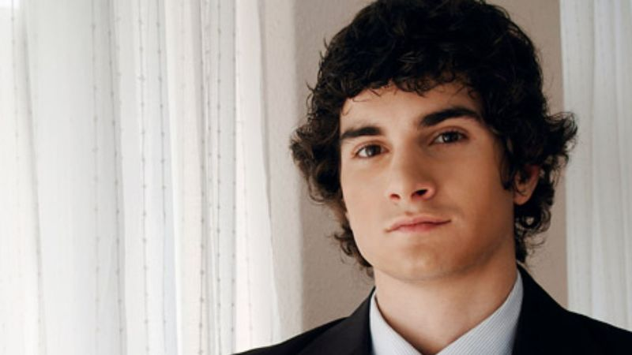
SOMERSET, NJ—In what local authorities are calling a "near tragedy," Charles Wentworth, a 17-year-old Rutgers Preparatory senior and member of the affluent Wentworth family, came perilously close to suffering a consequence resulting from his own wrongdoing Saturday.
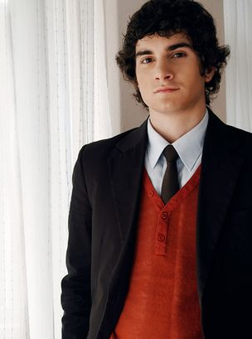
Wentworth made his senior photo shoot even after coming within inches of an actual repercussion from the accident.
Wentworth, reportedly ignoring the protests of his classmates, got behind the wheel of his turbocharged Supra 2000GT after consuming half the contents of a bottle of Goldschläger at a friend's party. While driving westbound on Route 27, a disoriented Wentworth drifted across two lanes of traffic and collided with a minivan carrying a family of four, bringing the teen face-to-face with a potentially life-altering lesson.
Wentworth escaped unscathed and unpunished, however, when his airbags deployed and a team of high-powered attorneys rushed to the scene and rescued him from the brink of personal responsibility.
"Amazingly, Mr. Wentworth did not experience a single repercussion for consuming alcohol under age or operating a motor vehicle while intoxicated, and is furthermore completely unaware that he did anything wrong," local police chief Marvin Taylor said. "He is a very lucky boy."
"If he had been driving just 5 mph faster, or if his parents hadn't had the influence to keep the matter out of court and the endless financial resources to lease a car of the exact same make and model to prevent him from having to face even the relatively trivial humiliation of being taunted by his peers for driving a slightly less expensive vehicle—my God, who knows what could have happened?" Taylor added. "He could have died or, worse, been held accountable for his actions."
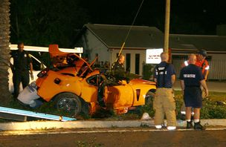
The accident
According to police reports that have since been shredded and stricken from Wentworth's permanent record, when briefly taken into custody, the privileged teenager began swearing, vomiting, and kicking at the windows of the squad car in which he was momentarily placed following the collision. Wentworth later said the only thing that got him through that dark time was thinking of his rich, well-connected loved ones. With them in mind, he repeatedly shouted, "Don't you know who I am?" and summoned the strength to refuse a field sobriety test.
"A lot of kids in Charles' situation would have confessed and accepted punishment for their mistake, but my son is strong," said Wentworth's father, aluminum magnate Herman Wentworth, who after arriving at the crash site told his son that "everything is taken care of," and while Charles sat in his father's BMW texting his friends, loudly threatened to call the police commissioner if any charges were pressed. "Charles would never allow himself to give up and gain valuable insight into the way things work in the real world without a fight."
District Judge and close friend of the Wentworth family Donald Lamb agreed.
"Charles is very lucky to be alive and well-off," Lamb told reporters. "The fact that he was able to walk away from this crash with no injuries, zero remorse, and his skewed priorities in one piece is a miracle."
Despite returning to the safety of his $2.3 million home, Wentworth's harrowing brush with consequence was not over.
A week after the near ordeal, Wentworth was again put in jeopardy of learning a lesson when he was nearly sentenced to 50 hours of community service. Tragedy was averted, however, when his mother paid a consultant to testify before the judge that Wentworth had suffered emotional trauma. Further, during this time, Wentworth was forced to put his video game on pause for several seconds in order to sign affidavits stating that the Breathalyzer was administered improperly.
"To think that I was that close to seeing that there is an entire society with its own laws and standards outside my protected sphere of wealth and privilege—it's frightening," Wentworth said. "It almost makes you consider your actions and their impact on others. Almost."
"I'm just grateful I can finally get back to my life as a self-centered prick who believes the entire world revolves around him," Wentworth added. "After all, I was just admitted to Columbia despite almost failing out of high school because I rarely attended class, and it would have been a shame to have had to defer for a semester just because of some legal...unpleasantry."
At press time, Wentworth is resting comfortably on a six-figure inheritance in a chaise lounge by his backyard pool. The other four victims of the crash remain in intensive care at St. Peter's University Hospital, suffering from conditions ranging from poor to lower-class.

